Adolfo Kaminsky Dies at 97; His Forgeries Saved Thousands of Jews
His talent for creating realistic documents helped children, their parents and others escape deportation to concentration camps, and in many cases to flee Nazi-occupied territory.

- • •

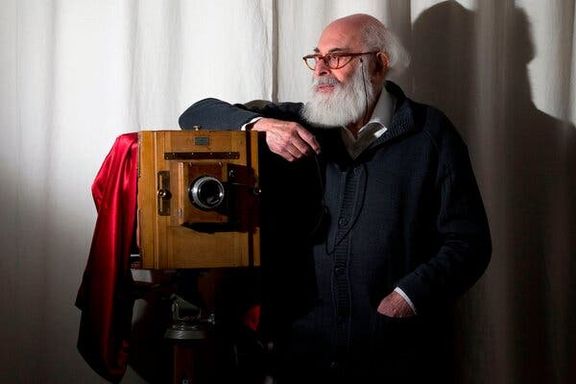
Adolfo Kaminsky at his home in Paris in 2012. After his wartime exploits in forgery, he became a photographer and photography teacher. Credit...Joël Saget/Agence France-Presse — Getty Images
By Joseph Berger
Jan. 9, 2023
Adolfo Kaminsky’s talent was as banal as could be: He knew how to remove supposedly indelible blue ink from paper. But it was a skill that helped save the lives of thousands of Jews in France during World War II.
He had learned how to remove such stains as a teenager working for a clothes dyer and dry cleaner in his Normandy town. When he joined the anti-Nazi resistance at 18, his expertise enabled him to erase Jewish-sounding names like Abraham or Isaac that were officially inscribed on French ID and food ration cards, and substitute them with typically gentile-sounding ones.
The forged documents allowed Jewish children, their parents and others to escape deportation to Auschwitz and other concentration camps, and in many cases to flee Nazi-occupied territory for safe havens.
At one point, Mr. Kaminsky was asked to produce 900 birth and baptismal certificates and ration cards for 300 Jewish children in institutional homes who were about to be rounded up. The aim was to deceive the Germans until the children could be smuggled out to rural families or convents, or to Switzerland and Spain. He was given three days to finish the assignment.
He toiled for two straight days, forcing himself to stay awake by telling himself: “In one hour I can make 30 blank documents. If I sleep for an hour 30 people will die.”
Mr. Kaminsky died on Monday at his home in Paris, his daughter Sarah Kaminsky said. He was 97.
His story reads like something out of a spy novel.
Using the pseudonym Julien Keller, Mr. Kaminsky was a key operative in a Paris underground laboratory whose members — all working for no pay and risking a quick death if discovered — adopted aliases like Water Lily, Penguin and Otter, and often contrived documents from scratch.
Mr. Kaminsky learned to fashion various typefaces, a skill he had picked up in elementary school while editing a school newspaper, and was able to imitate those used by the authorities. He pressed paper so that it, too, resembled the kind used on official documents, and photoengraved his own rubber stamps, letterheads and watermarks.
Word of the cell spread to other resistance groups, and soon it was producing 500 documents a week, receiving orders from partisans in several European countries. Mr. Kaminsky estimated that the underground network he was part of helped save 10,000 people, most of them children.
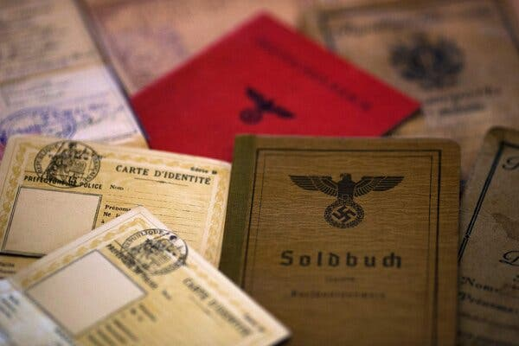
Photographed at his home in 2012, some of the documents Mr. Kaminsky used to forge fake names and identifications in an effort to save Jews from deportation to death camps. Credit...Joël Saget/Agence France-Presse — Getty Images
After Paris was liberated, Mr. Kaminsky went to work for the revived French government, where he fabricated documents that allowed intelligence agents to penetrate Nazi territory in order to gather evidence about the death camps.
He continued to forge documents for three decades after the war, aiding insurgents in British-mandate Palestine, French Algeria, South Africa and Latin America. He also fabricated papers for Americans trying to evade the military draft during the Vietnam War.
“I saved lives because I can’t deal with unnecessary deaths — I just can’t,” he told The New York Times in 2016. “All humans are equal, whatever their origins, their beliefs, their skin color. There are no superiors, no inferiors. That is not acceptable for me.”
Mr. Kaminsky was the subject that year of an Emmy Award-winning documentary short, “The

As a teenager, Adolfo Kaminsky saved thousands of lives by forging passports to help children flee the Nazis. He spent his life helping others escape atrocities around the world.
“How do you become a forger? Out of necessity and by chance,” says Adolfo Kaminsky. As a teenager, Kaminsky saved thousands of lives by forging passports to help children flee the Nazis. He spent his life helping others escape atrocities around the world.
16:21The Forger
As a teenager, Adolfo Kaminsky saved thousands of lives by forging passports to help children flee the Nazis. He spent his life helping others escape atrocities around the world.
Mr. Kaminsky finally gave up the forger’s life in the early 1970s and went on to earn a living as a photographer and photography instructor in Paris, shooting evocative scenes like rain-slicked cobblestones and nighttime lovers on a bench far removed from the tumult of war.
Adolfo Kaminsky was born on Oct. 1, 1925, in Buenos Aires. His parents, Salomon and Anna (Kinoël) Kaminsky, were Russian Jews who met in Paris in 1916. His mother had fled the pogroms in Russia; his father was a journalist for a Jewish Marxist newspaper. When the Bolsheviks overthrew the czarist government, France expelled sympathizers of the new regime, and the Kaminskys fled to Argentina, where their two other sons were also born.
By the early 1930s, the Kaminskys were able to return to France and settle in the town of Vire in Normandy. Adolfo left school at 13 to help an uncle run his market stall, but finding him overbearing, the boy left to work in a factory that made airplane instruments.
The Germans invaded France in 1940. They took over the Normandy factory and dismissed all Jewish workers. Needing work to help his family, Adolfo answered an ad for an apprentice dyer in a business that converted military uniforms and greatcoats to civilian wear. The owner, a chemical engineer, taught him the secrets of altering and removing colors. Adolfo became an expert at effacing the most stubborn stains.
He became so interested in chemistry that he took a side job as an assistant for a chemist at a dairy that churned butter. To gauge the fat content of the cream brought by farmers, the dairy would insert methylene blue in a sample and waited for its lactic acid to dissolve the color. That was how Adolfo learned that lactic acid was the best eraser of Waterman blue ink, the kind used on ID cards.
In 1941, the Kaminskys were arrested and sent to Drancy, an internment camp near Paris that was a way station to the death camps. Thanks to their Argentine passports, they were released after three months.
But the family soon feared that those passports would no longer protect them, and so Adolfo, by then 18, was dispatched to secure documents from the French underground that would disguise the fact that they were Jews. When the resistance agents learned of his expertise, they recruited him.
A memoir, told in his voice but written by his daughter Sarah Kaminsky and published in English in 2016 with the title “Adolfo Kaminsky: A Forger’s Life,” chronicles how Mr. Kaminsky began his resistance work in earnest after learning that his mother had been killed on a train returning from Paris, where she had gone to warn her brother of his impending arrest. Furious, he committed several acts of sabotage, using chemicals to rust railway equipment and corrode transmission lines.
He had sought vengeance, he said, and needed “consolation for his sadness.”
“For the first time I didn’t feel entirely impotent,” he said.
Forging documents was perilous work. Once, on the Paris Metro, a policeman approached him to inspect his satchel, which contained blank identity documents and forging tools. Thinking fast, Mr. Kaminsky told him that it contained sandwiches and asked him if he wanted one. The policeman moved on.
But several of Mr. Kaminsky’s underground colleagues were arrested and killed, and the strain of doing such painstaking work for hours on end cost him his sight in one eye.
His first marriage, in 1950, to Jeanine Korngold, ended in divorce in 1952. He married Leila Bendjebour in 1974.
In addition to his daughter Sarah, from his second marriage, Mr. Kaminsky is survived by his wife; their two sons, Atahualpa and José-Youcef; a daughter from his first marriage, Marthe; a sister, Pauline Gerlich; and nine grandchildren. A son from his first marriage, Serge, died of a heart attack in 2021.
In a 2010 talk in Paris, Sarah Kaminsky recalled her first glimpse of her father’s life as a forger. She had received a bad grade in school, she said, and needed her mother’s signature as proof that she had informed her parents. So she faked it.
Her mother quickly perceived a forgery and rebuked her, but her father responded with a laugh.
“But really, Sarah, you could have worked harder,” he said of her effort. “Can’t you see it’s really too small?”

Alex Traub contributed reporting.
Joseph Berger was a reporter and editor at The New York Times for 30 years. He is the author of a forthcoming biography of Elie Wiesel. @joeberg

